**PAPER TITLE, CAPITALIZE ALL LETTERS, IN 14 PT BOLD TIME NEW ROMAN (USE STYLE: PAPER TITLE)**

**First Authora*, Second Authorb (The Authors' Names are in Bold 11pt Time New Roman)**

aFirst affiliation, address, Country (Time New Roman 10pt)

bSecond affiliation, address, Country (Time New Roman 10pt)

* Corresponding author: [abcde@humg.edu.vn](mailto:abcdefghikf@humg.edu.vn) (Time New Roman 10pt)

**Abstract:** *This electronic document is a “live” template and already defines the components of your paper [title, text, heads, etc.] in its style sheet. (Time New Roman, 10 pt)*

Key words: component, formatting; style; styling; insert (key words) (Time New Roman, 10 pt)

# 1. Introduction (Time New Roman, 11 pt)

This template, is provided by IEEE eXpress Conference Publishing, modified in MS Word, provides authors with most of the formatting specifications needed for preparing electronic versions of their papers. All standard paper components have been specified for three reasons: (1) ease of use when formatting individual papers, (2) automatic compliance to electronic requirements that facilitate the concurrent or later production of electronic products, and (3) conformity of style throughout a conference proceedings. Margins, column widths, line spacing, and type styles are built-in; examples of the type styles are provided throughout this document and are identified in italic type, within parentheses, following the example. Some components, such as multi-leveled equations, graphics, and tables are not prescribed, although the various table text styles are provided. The formatter will need to create these components, incorporating the applicable criteria that follow.

# 2. Ease of Use

## 2.1 Selecting a Template

*2.1.1 Italic time new roman 11pt font*

First, confirm that you have the correct template for your paper size. This template has been tailored for output on the A4 paper size.

*2.1.2 Italic time new roman 11pt font*

If you are using US letter-sized paper, please close this file and download the file “MSW_USltr_format”.

## 2.2 Maintaining the Integrity of the Specifications

The template is used to format your paper and style the text. All margins, column widths, line spaces, and text fonts are prescribed; please do not alter them. You may note peculiarities. For example, the head margin in this template measures proportionately more than is customary. This measurement and others are deliberate, using specifications that anticipate your paper as one part of the entire proceedings, and not as an independent document. Please do not revise any of the current designations.

# 3. Prepare Your Paper Before Styling

Before you begin to format your paper, first write, and save the content as a separate text file. Keep your text and graphic files separate until after the text has been formatted and styled. Do not use hard tabs, and limit use of hard returns to only one return at the end of a paragraph. Do not add any kind of pagination anywhere in the paper. Do not number text heads-the template will do that for you.

Finally, complete content and organizational editing before formatting. Please take note of the following items when proofreading spelling and grammar:

## 3.1 Abbreviations and Acronyms

Define abbreviations and acronyms the first time they are used in the text, even after they have been defined in the abstract. Abbreviations such as IEEE, SI, MKS, CGS, sc, dc do not have to be defined. Do not use abbreviations in the title or heads unless they are unavoidable.

## 3.2 Units

* Use a zero before decimal points: “0.25,” not “.25.” Use “cm3,” not “cc.” (*bullet list*)

## 3.3 Equations

Number equations consecutively. Equation numbers, within parentheses, are to position flush right, as in (1), using a right tab stop. To make your equations more compact, you may use the solidus (/), the exp function, or appropriate exponents. Italicize Roman symbols for quantities and variables, but not Greek symbols. Use a long dash rather than a hyphen for a minus sign. Punctuate equations with commas or periods when they are part of a sentence, as in

|  |  |
| --- | --- |
| a+b=c | (1) |

Note that the equation is centered using a center tab stop. Be sure that the symbols in your equation have been defined before or immediately following the equation. Use “(1),” not “Eq. (1)” or “equation (1),” except at the beginning of a sentence: “Equation (1) is ...”

## 3.4 Some Common Mistakes

* The word “data” is plural, not singular.
* The subscript for the permeability of vacuum **0, and other common scientific constants, is zero with subscript formatting, not a lowercase letter “o.”
* In American English, commas, semi-/colons, periods, question, and exclamation marks are located within quotation marks only when a complete thought or name is cited, such as a title or full quotation.
* A graph within a graph is an “inset,” not an “insert.” The word alternatively is preferred to the word “alternately” (unless you really mean something that alternates).
* Do not use the word “essentially” to mean “approximately” or “effectively.”

# 4. Using the Template

After the text edit has been completed, the paper is ready for the template. Duplicate the template file by using the Save As command, and use the naming convention prescribed by your conference for the name of your paper. In this newly created file, highlight all of the contents and import your prepared text file. You are now ready to style your paper; use the scroll down window on the left of the MS Word Formatting toolbar.

## 4.1 Authors and Affiliations

The template is designed so that author affiliations are not repeated each time for multiple authors of the same affiliation. Please keep your affiliations as succinct as possible (for example, do not differentiate among departments of the same organization). This template was designed for two affiliations.

## 4.2 Identify the Headings

Headings, or heads, are organizational devices that guide the reader through your paper. There are two types: component heads and text heads.

## 4.3 Figures and Tables

### *Positioning Figures and Tables: Place figures and tables at the top and bottom of columns. Avoid placing them in the middle of columns. Large figures and tables may span across both columns. Figure captions should be below the figures; table heads should appear above the tables. Insert figures and tables after they are cited in the text. Use the abbreviation “Fig. 1,” even at the beginning of a sentence.*

Figure Labels: Use 10 point Times New Roman for Figure labels. Use words rather than symbols or abbreviations when writing Figure axis labels to avoid confusing the reader. As an example, write the quantity “Magnetization,” or “Magnetization, M,” not just “M.” If including units in the label, present them within parentheses.

Table 1. The subsidence measurement data

Unit: meter

|  |  |  |  |  |
| --- | --- | --- | --- | --- |
| Name of point | Measurement subsidence | | | |
| 0 month | 5 month | 10 month | 15 month |
| A1 | 0 | -0.190 | -0.339 | -0.395 |
| A2 | 0 | -0.166 | -0.203 | -0.230 |
| 7 | 0 | -0.113 | -0.189 | -0.241 |
| 12 | 0 | -0.187 | -0.251 | -0.280 |

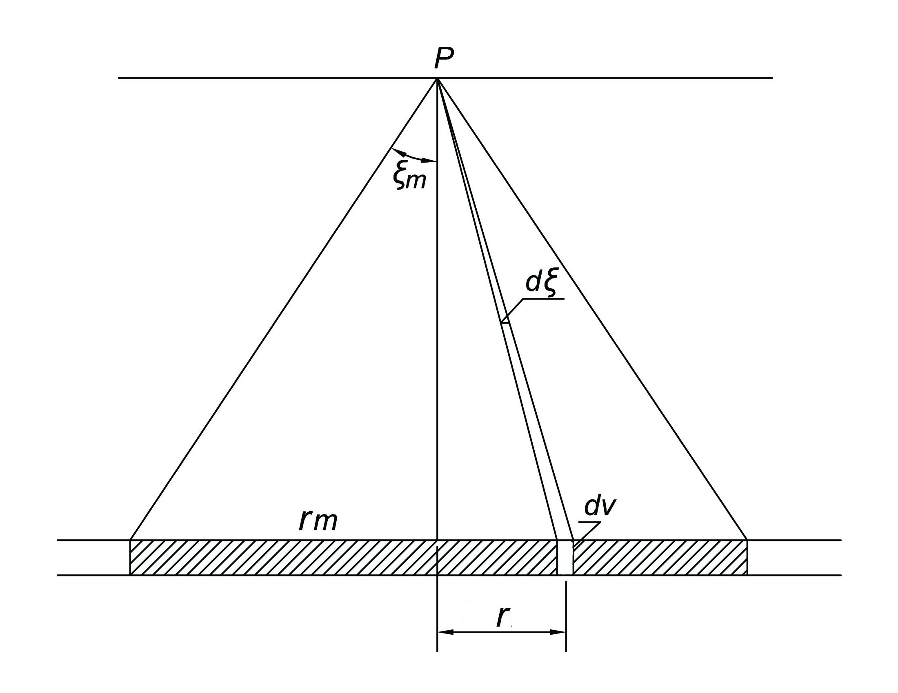

Fig1. Example of a figure caption.

##### **Acknowledgment**

The preferred spelling of the word “acknowledgment” in America is without an “e” after the “g.” Avoid the stilted expression “one of us (R. B. G.) thanks ...”. Instead, try “R. B. G. thanks...”. Put sponsor acknowledgments in the unnumbered footnote on the first page.

##### **References**

Deal and Grove (1965) used two formats for in-text citations: (Author Date) and Author (Date). Start each reference with a new line, no indentation (Fachinger, 2006). Use only the initial(s) of the author’s given name, not the full name. If the reference list includes 2 or more entries by the same author(s), list them in chronological order with the earliest first. Arrange reference entries in one alphabetical sequence by the surname of the first author or organizational name, or by the first word of the title if there is no author (Fachinger et al., 2004). Ignore the words A, An, and The when alphabetizing by title. Place of publication: use only the first listed place when there are multiple places of publication. If a publication place is little known or shares its name, you can add the state or country.

Clark, T., Woodley, R., De Halas, D., 1962. Gas-Graphite Systems, in *“Nuclear Graphite”* R. Nightingale, Editor. Academic Press, New York, p. 387.

Deal, B., Grove, A., 1965. General Relationship for the Thermal Oxidation of Silicon, Journal of Applied Physics 36, p. 3770.

Deep-Burn Project: Annual Report for 2009, 2009. Idaho National Laboratory.

Fachinger, J., den Exter, M., Grambow, B., Holgerson, S., Landesmann, C., Titov, M., Podruhzina, T., 2004. “Behavior of spent HTR fuel elements in aquatic phases of repository host rock formations,” 2nd International Topical Meeting on High Temperature Reactor Technology. Beijing, China, paper #B08.

Fachinger, J., 2006. Behavior of HTR Fuel Elements in Aquatic Phases of Repository Host Rock Formations. Nuclear Engineering & Design 236, p. 54.